
Hawaii High School Athletic Association
----------------------------------------------------------------------------------
 P.O. BOX 11419  HONOLULU, HAWAII 96828 
PHONE: (808) 800-4092
 www.hhsaa.org - info@hhsaa.org 

2025 HAWAII ARMY NATIONAL GUARD / HHSAA
AIR RIFLERY
SOUVENIR T-SHIRT PRE-ORDER FORM

School requests to order the following sizes of the souvenir Drifit T-shirts at $20.00 per shirt.
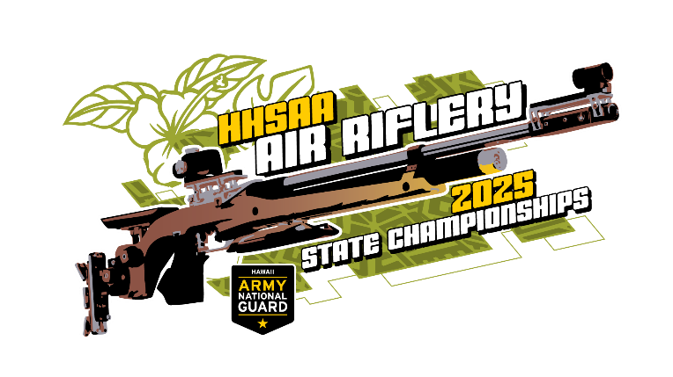
Size | Quantity | Price | Total
Small |  | $20.00
Medium |  | $20.00
Large |  | $20.00
X-Large |  | $20.00
XXL |  | $20.00
 |  | GRAND TOTAL

Email preorders to your respective host (see below) school.

Quantities limited. Checks payable to HHSAA may be brought to the tournament site.

TOURNAMENT HOST:

Contact person:

Daytime phone:

Email Address:
Kelly Sur, Athletic Director
Radford High School
E-mail: kelly.sur@k12.hi.us

