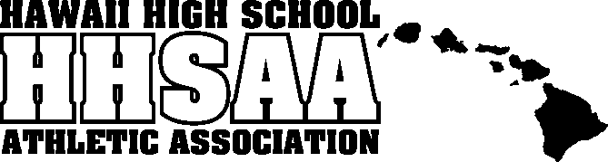
Hawaii High School Athletic Association
----------------------------------------------------------------------------------
 P.O. BOX 11419  HONOLULU, HAWAII 96828 
PHONE: (808) 800-4092
 www.hhsaa.org - info@hhsaa.org 

2025 HHSAA BOWLING STATE TOURNAMENT
SOUVENIR T-SHIRT PRE-ORDER FORM

School requests to order the following sizes of the souvenir T-shirts at $20.00 per shirt.

Size | Quantity | Price | Total
Small |  | $20.00
Medium |  | $20.00
Large |  | $20.00
X-Large |  | $20.00
XX-Large |  | $20.00
 |  | GRAND TOTAL
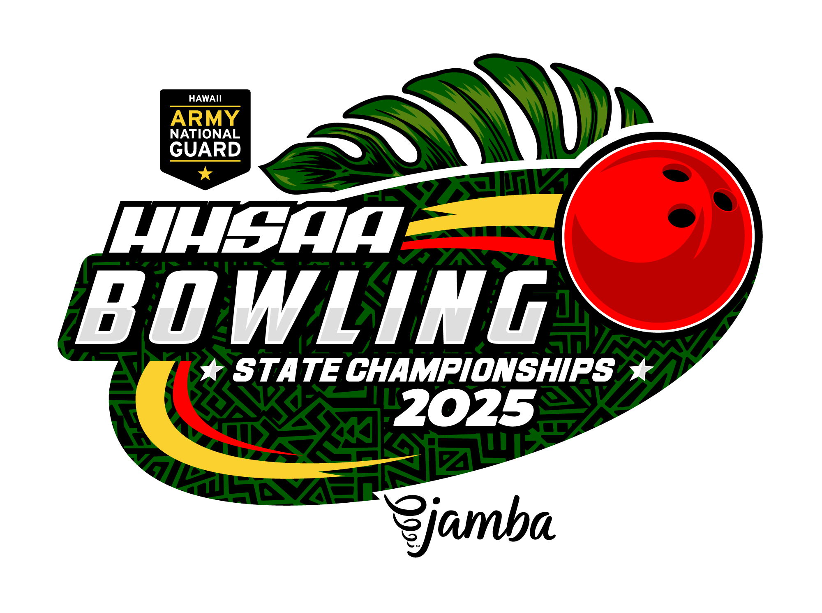

Email preorders to your respective host (see below) school. Checks payable to HHSAA may be brought to the tournament site of teams first game. Note: preorders must be paid in full by first day of the tournament or shirts will be released to the general public.

Colleen Carrington

Team info:

Contact person:

Daytime phone:

ILH Office
E-mail: carrington@ilhsports.com

