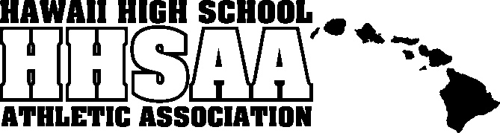
Hawaii High School Athletic Association
P.O. BOX 62029 • HONOLULU, HAWAII 96839
PHONE: (808) 800-4092
www.sportshigh.com • info@hhsaa.org

2022 HHSAA JUDO STATE TOURNAMENT
SOUVENIR T-SHIRT PRE-ORDER FORM

School requests to order the following sizes of the souvenir T-shirts at $20.00 per shirt.
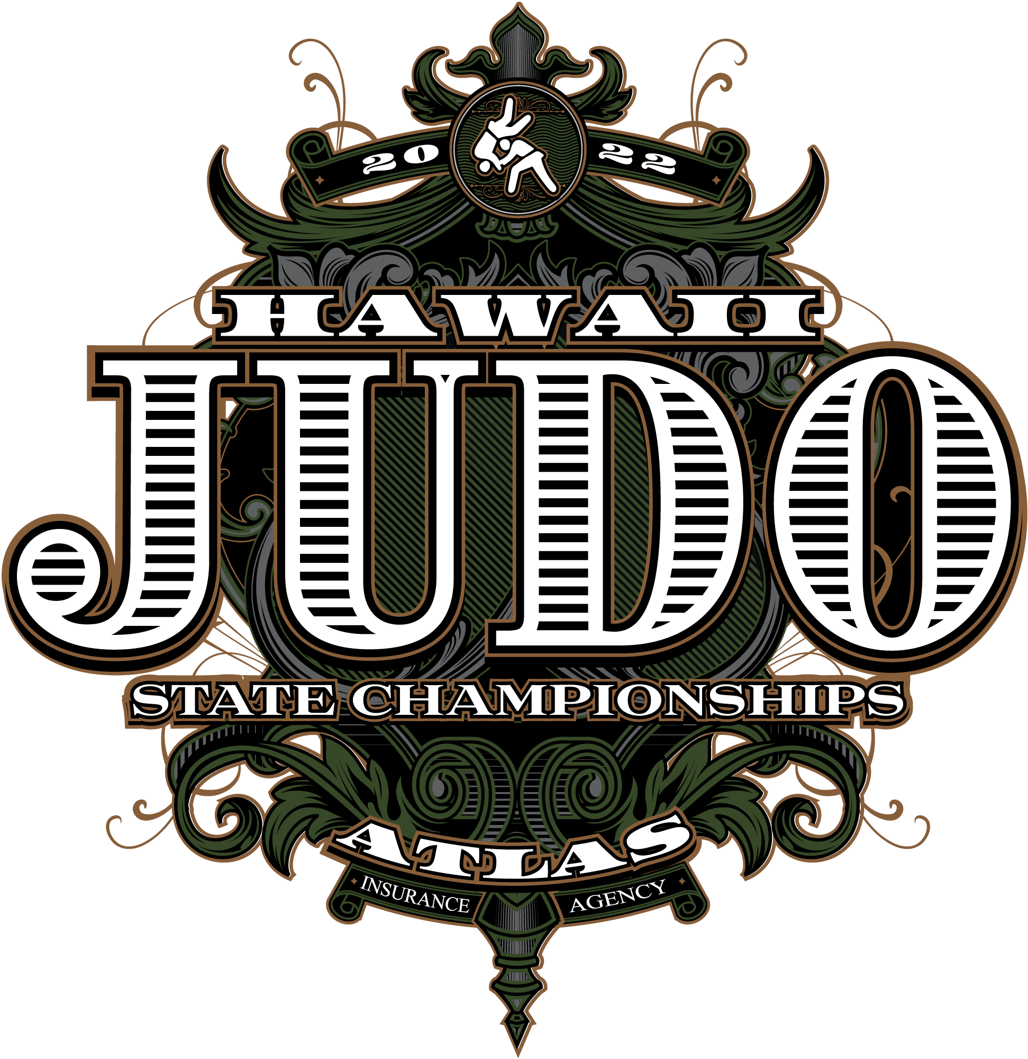
Size | Quantity | Price | Total
Small |  | $20.00
Medium |  | $20.00
Large |  | $20.00
X-Large |  | $20.00
XX-Large |  | $20.00
 |  | GRAND TOTAL

Email preorders to your respective host (see below) school. Checks payable to HHSAA may be brought to the tournament site of teams first game. Note: preorders must be paid in full by first day of the tournament or shirts will be released to the general public.

Contact person: __________________________________

Daytime phone: __________________________________

E-mail: _________________________________________

Send preorders to:
Joel Kawachi, Athletic Director
Moanalua High School
E-mail: joel.kawachi@k12.hi.us

