Hawaii High School Athletic Association
P.O. BOX 62029  HONOLULU, HAWAII 96839
PHONE: (808) 800-4092
www.sportshigh.com - info@hhsaa.org

2019 HAWAII MEDICAL SERVICE ASSOCIATION TENNIS STATE TOURNAMENT SOUVENIR T-SHIRT PRE-ORDER FORM

School requests to order the following sizes of the souvenir T-shirts at $20.00 per shirt.

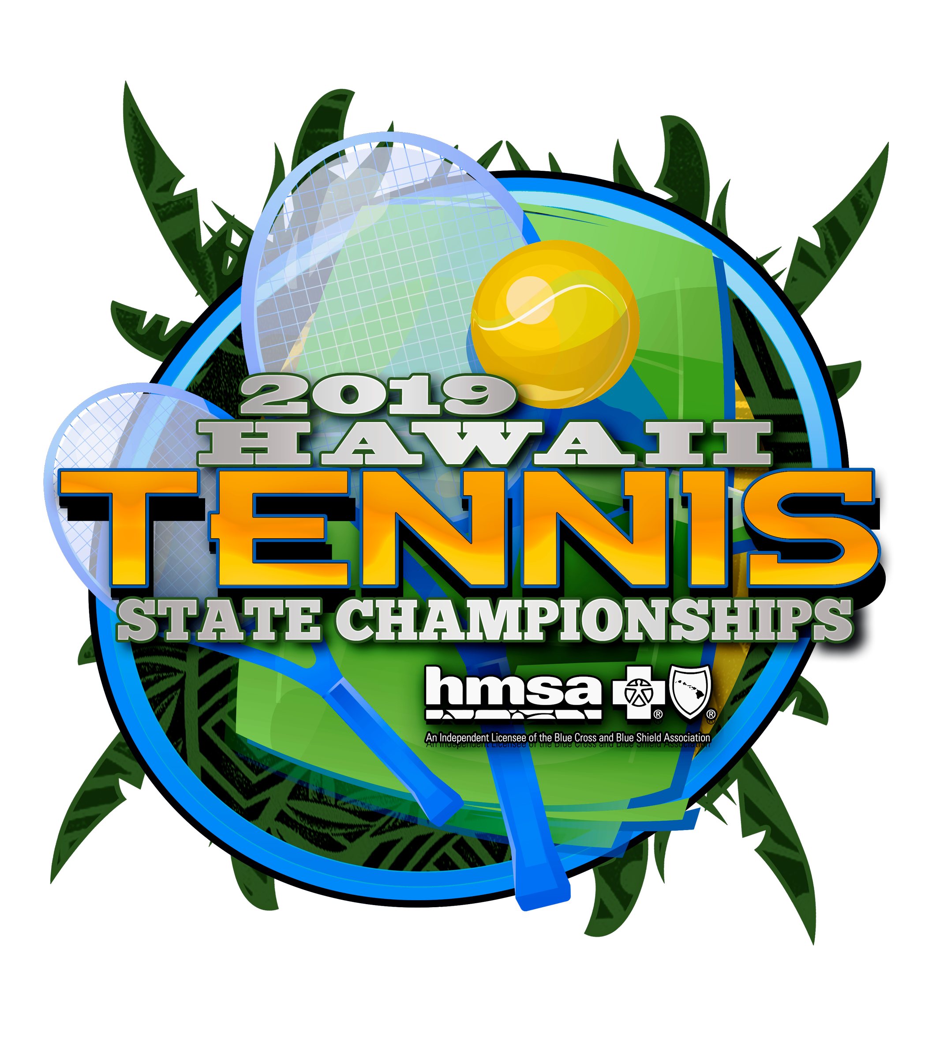
Size | Quantity | Price | Total
Small |  | $20.00
Medium |  | $20.00
Large |  | $20.00
X-Large |  | $20.00
XX-Large |  | $20.00
 |  | GRAND TOTAL

Email preorders to the host school. Checks payable to HHSAA may be brought to the coaches meeting or the first day of the tournament. Note: preorders must be paid in full by first day of the tournament or shirts will be released to the general public for sale.

Contact person: ________________________

Daytime phone: ________________________

Email Address: ________________________

HOST SCHOOL:
Nicole Vedelli, Athletic Director
Parker School
E-mail: nvedelli@parkerschoolhawaii.org

