
Hawaii High School Athletic Association
P.O. BOX 11419  HONOLULU, HAWAII 96828
PHONE: (808) 800-4092
www.hhsaa.org - info@hhsaa.org

2026 ISLAND INSURANCE / HHSAA TENNIS STATE TOURNAMENT SOUVENIR T-SHIRT PRE-ORDER FORM

School requests to order the following sizes of the souvenir T-shirts at $20.00 per shirt.

Size | Quantity | Price | Total
Small |  | $20.00
Medium |  | $20.00
Large |  | $20.00
X-Large |  | $20.00
XX-Large |  | $20.00
 |  | GRAND TOTAL

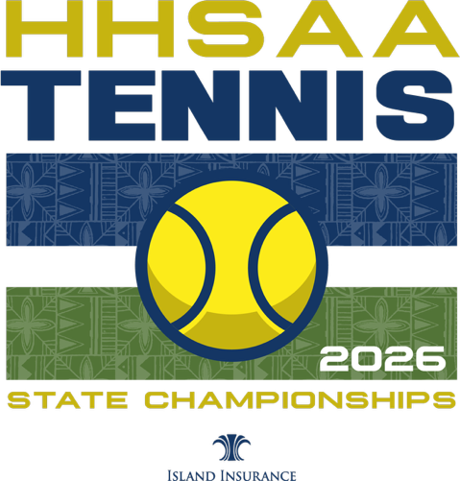

Email preorders to the host school. Checks payable to HHSAA may be brought to the coaches meeting or the first day of the tournament. Note: preorders must be paid in full by the first day of the tournament or shirts will be released to the public for sale.

HOST SCHOOL:
Ross Kinsler, Athletic Director

Contact person:

Daytime phone:

Email:
Hawaii School for Girls at La Pietra
E-mail: rkinsler@lapietra.edu

Preorder form Due:
Sunday, May 3, 1pm

