
Hawaii High School Athletic Association
----------------------------------------------------------------------------------
 P.O. BOX 11419  HONOLULU, HAWAII 96828 
PHONE: (808) 800-4092
 www.hhsaa.org - info@hhsaa.org 

2026 NEW CITY NISSAN / HHSAA BOYS VOLLEYBALL
SOUVENIR T-SHIRT PRE-ORDER FORM

School requests to order the following sizes of the souvenir T-shirts at $20.00 per shirt.

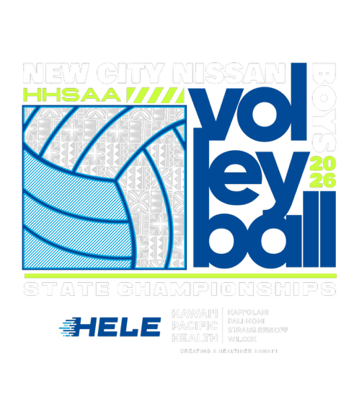
Size | Quantity | Price | Total
Small |  | $20.00
Medium |  | $20.00
Large |  | $20.00
X-Large |  | $20.00
XX-Large |  | $20.00
 |  | GRAND TOTAL

E-mail preorders to the HHSAA office at the contact information listed below. Checks payable to HHSAA may be brought to the site of team’s first game. Preorders must be paid in full by first day of the tournament or shirts will be released to the public for sale.

Contact person:

Daytime phone:

E-mail:

DIVISION I & II:
Russell Aoki
HHSAA
E-mail: aoki@hhsaa.org

Preorders are due:
Sunday, May 10, 1pm

